**FMEA document to be created:**

Here, there is separate team called quality team where the transition manager during the ramp phase writes an email for creation / completion of FMEA document to quality team

If you see in the below screen shot this is how the transition manager writes an email to quality team:

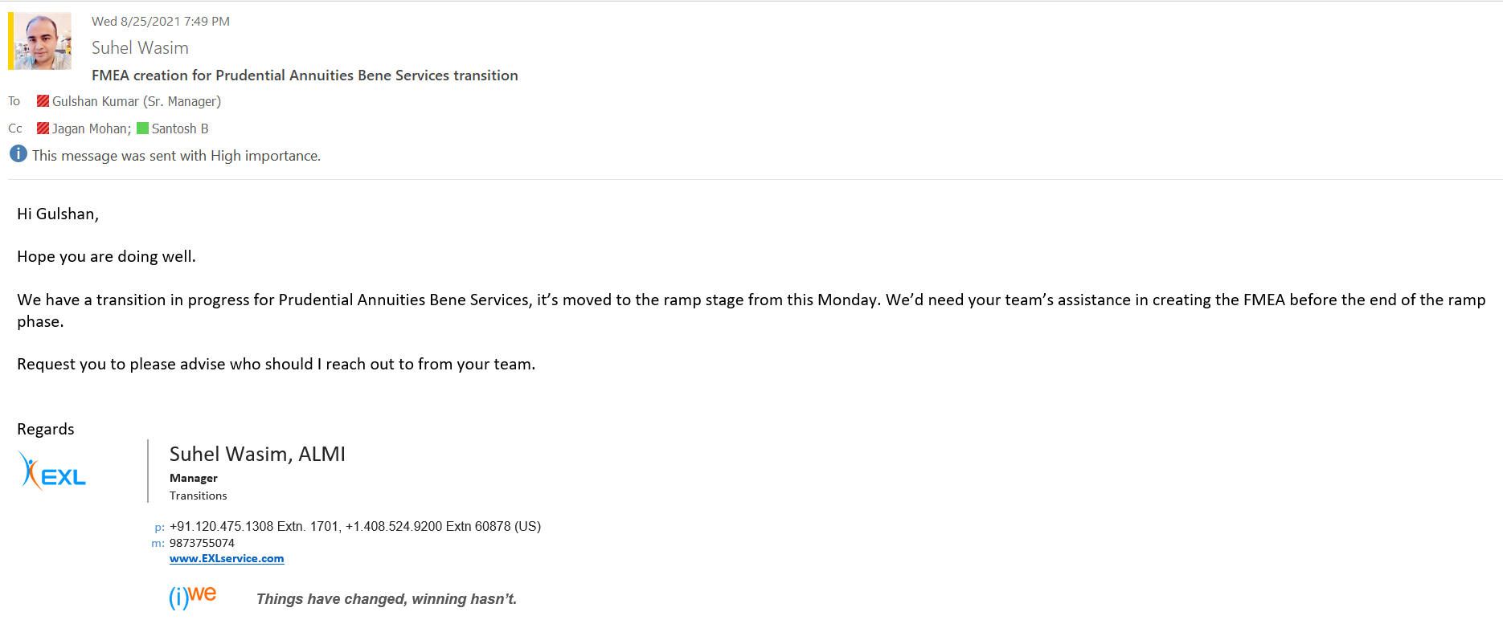

It also seems that the transition manager has also provided more details about the transition as it looks like the the quality team has not create the FMEA document Here the transition manager only provides the details of each process.

